**2024 Food & Benefit Assistance Programs**

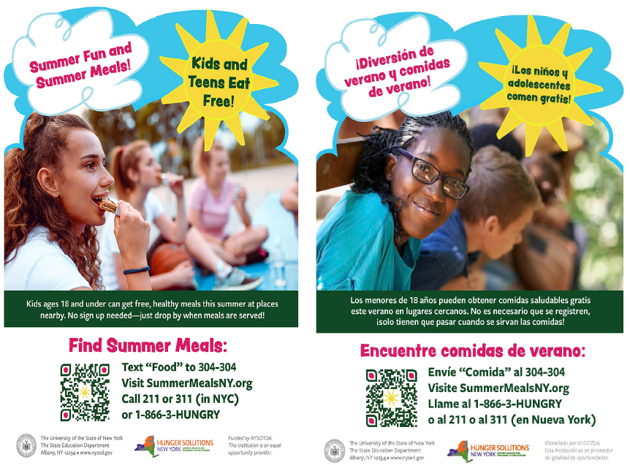

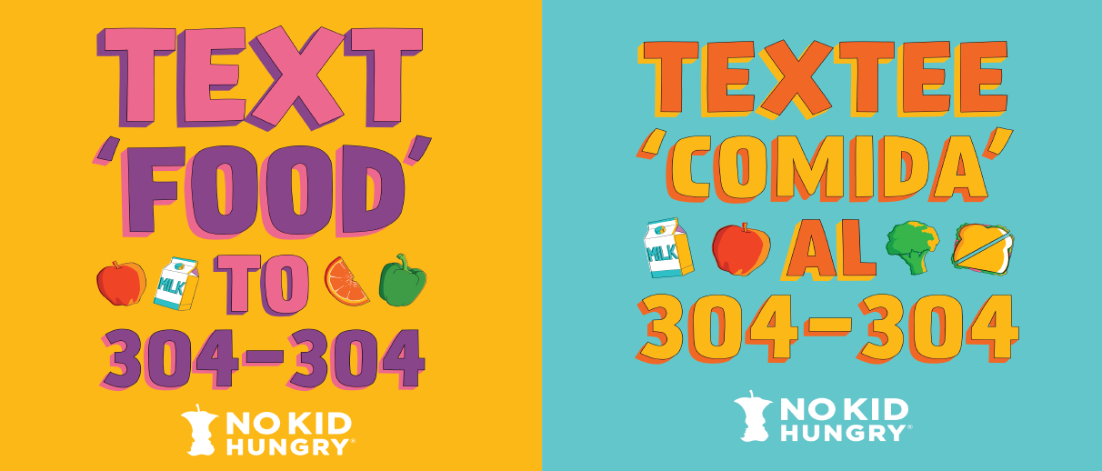

**Local Area Food Pantries**

[Suffolk County Government (.gov)](\\\\share-03\\Admin\\Food Service\\Wellness\\Wellness - Food Resources\\Suffolk County Government (.gov)https:\\suffolkcountyny.gov › FOOD PANTRIES)

[https://suffolkcountyny.gov › FOOD PANTRIES](\\\\share-03\\Admin\\Food Service\\Wellness\\Wellness - Food Resources\\Suffolk County Government (.gov)https:\\suffolkcountyny.gov › FOOD PANTRIES)

**Centereach Area**

* Centereach Assumption of BVM Outreach 20 Chestnut St. Centereach, NY 11720, 631-585-8760 Tues/Weds/Fri 11am-1pm *by appointment only
* Lighthouse Mission 2150 Middle Country Rd. Centereach, NY 11720, 631-758-7584 Friday 12pm-1pm
* Our Savior Lutheran Church 140 Mark Tree Rd. Centereach, NY 11720, 631-588-2757 Mon.-Thurs. 3pm-5pm
* #forlongisland food pantry, Centereach, NY, 631-602-8139
* FSL – Parent to Parent Food Distribution, Centereach, NY, 631-223-5030

**Selden Area**

* Selden Hope Lutheran Church 46 Dare Rd. Selden, NY 11784, 631-732-2511 Thursdays 12:30pm - 2pm
* St. Cuthbert's Episcopal Church 18 Magnolia Place Selden, NY 11784, 631-732-8773 Fridays 10am - 12pm
* St. Margaret of Scotland 81 College Rd. Selden, NY 11784, 631-732-3131 By appointment only
* Suffolk Community College 533 College Rd. Selden, NY 11784, 631-451-4812 Mon-Thurs. 9 - 5 Fri. 9 -3

**Lake Grove**

* Lake Grove United Methodist Church of Lake Ronkonkoma 792 Hawkins Ave Lake Grove, NY 11755 631-588-5856 1st & 3rd Tuesdays of the

**Port Jefferson**

* Port Jefferson Christ Church Port Jefferson Station (CCPJS) 545 Old Town Rd. Port Jefferson Sta., NY 11776, 631-473-4734 Tuesdays 10am - 1pm
* Lighthouse Mission Corner of Hallock Rd. & Route 112 - Commuter Parking lot next door to 7-11 Port Jefferson Sta., NY 11776, 631-758-7584 Thursdays 12pm - 1pm
* Open Cupboard FP @ Infant Jesus Church 110 Myrtle Ave. Port Jefferson, NY 11776, 631-331-6145 Tues./Thurs. 10am - 12pm
* St. Gerard Majella Parish Outreach 300 Terryville Rd. Port Jefferson Sta., NY 11776, 631-473-2900 Tues. 11:30am-3pm, Weds. 12:30pm-3pm, Thurs. 11:30am-1:30pm & 4pm-5pm
* Sunshine Prevention Center FP 468 Boyle Rd. Port Jefferson Sta., NY 11776, 631-476-3099 By Appointment only

**CORAM**

* Faith Baptist Church Food Pantry 11 Teller Ave. Coram, NY 11727, 631-732-1133 Mon. - Fri. 9am-2pm
* Gordon Heights SDA Food Pantry 21 Teller Ave. Coram, NY 11727, 631-698-0912 Tuesday 4pm - 6pm
* Lighthouse Mission Mobile Food Pantry 79 Middle Country Rd. Coram, NY 11727, Mondays 12pm - 1pm New Beginnings Christian Center 241 Middle Country Rd. Coram, NY 11727, 631-736-7000 Saturdays 9am - 11am
* St. Francis Cabrini 134 Middle Country Rd. Coram, NY 11727, 631-736-6835 Mon./Weds. /Fri. 10am - 1pm
* The Ministries 3680 Route 112 Coram, NY 11727, 631-736-4800 Mon. - Thurs. 1pm-4:30pm

**Lake Ronkonkoma/Ronkonkoma**

* Church of Elizabeth Ann Seton Parish Outreach 800 Portion Rd. Lake Ronkonkoma, NY 11779, 631-737-4416 Mon./Weds. 9:30-12:30 & 1:30 Tues./Thurs. 1:30-4:30
* United Methodist Church of Lake Ronkonkoma 792 Hawkins Ave. Lake Ronkonkoma, NY 11779, 631-588-5856 1st & 3rd Tuesdays of the month 3pm - 5pm
* Lighthouse Mission 565 Portion Rd. Lake Ronkonkoma, NY 11779, 631-758-7584 Mondays 12pm - 1pm
* St. Mary's Episcopal Church 315 Lake Shore Rd. Lake Ronkonkoma, NY 11779, 631-588-1888 Friday 10am - 12pm
* Charlotte's Table 939 Johnson Ave. Ronkonkoma, NY 11779, 631-471-7242 Weds. 2pm-7pm & Veterans
* Joseph's Church 25 Churck St. Ronkonkoma, NY 11779, 631-981-6888 Call for an Appointment

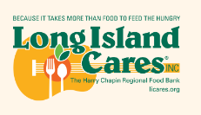 [**https://www.licares.org/find-food/**](https://www.licares.org/find-food/)

<https://www.licares.org/>

<https://www.licares.org/what-we-do/feed-long-island/>

<https://www.licares.org/what-we-do/feed-long-island/first-stop-food-pantries/>

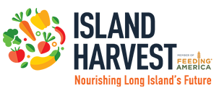 [**https://www.islandharvest.org/find-help/find-a-food-pantry/**](https://www.islandharvest.org/find-help/find-a-food-pantry/)

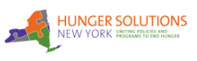 [**https://hungersolutionsny.org/find-food-help/**](https://hungersolutionsny.org/find-food-help/)

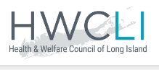 [**https://hwcli.com/work-we-do/direct-services**](https://hwcli.com/work-we-do/direct-services)**/**

<https://hwcli.com/work-we-do/coalition-grassroots-organizing/emergency-food-shelter-program/>

<https://hwcli.com/work-we-do/direct-services/snap/>

<https://hwcli.com/work-we-do/direct-services/emergency-rental-assistance-program-erap/>

**English, Español and Other Languages SNAP prescreening tool:**

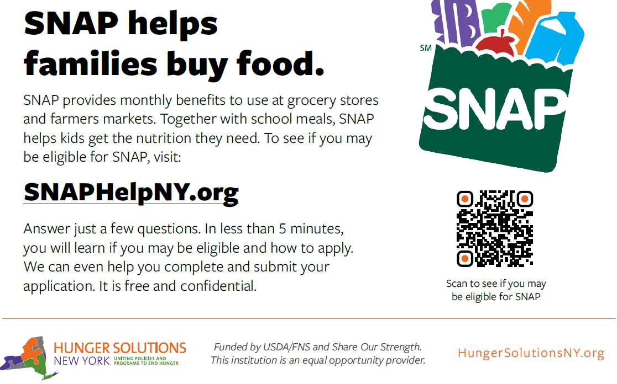

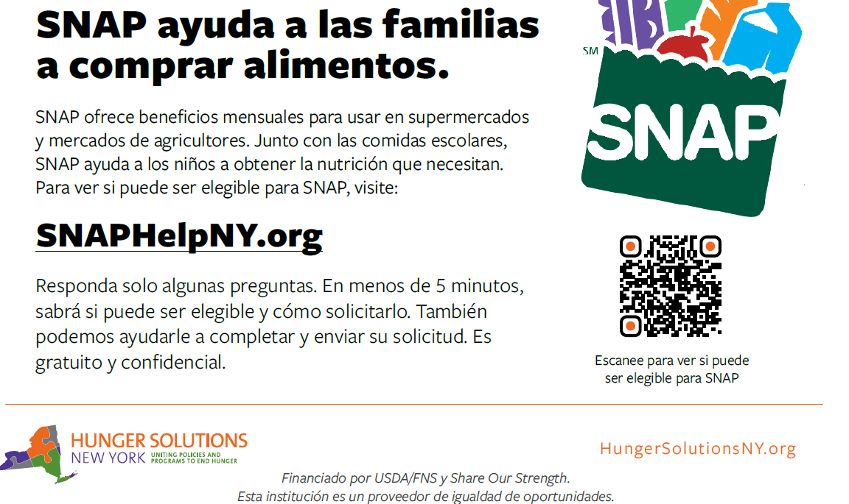

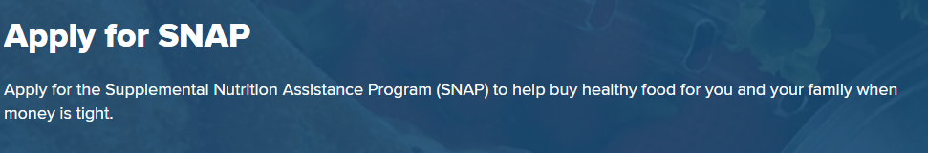

**https://www.ny.gov/services/apply-snap**

 [**https://otda.ny.gov/programs**](https://otda.ny.gov/programs)

**https://otda.ny.gov/programs/summer-ebt/**

NYS OTDA – Office of Temporary Disability Assistance: **1-800-342-3009**

Beginning in 2024, New York State will launch **Summer EBT**, a new program that provides low-income families with food benefits to help cover the cost of groceries when school is out of session. Summer is the time when many children lose access to free meals they get at school. Most eligible children will receive **Summer EBT.**

**Eligibility**

To be automatically eligible for **Summer EBT** food benefits:

* A child must receive Supplemental Nutrition Assistance Program (SNAP) and/or Temporary Assistance (cash) benefits, or be directly certified for free meals through Medicaid, **OR**
* A child must be determined eligible for free/reduced price school meals by their school.

These children will receive benefits automatically and **DO NOT need to apply**. Most eligible children will receive their benefits this way. These families will receive a letter this summer letting them know that their child is eligible.

**If your child is not automatically eligible**, you must apply to receive **Summer EBT** benefits.  
To be eligible with an application:

* A child must attend a school that participates in the National School Lunch Program (NSLP), **AND**
* The household's income must be at or below the income limits for eligibility for free/reduced price school meals (use “reduced price” scale for 185% federal poverty level).

**Benefits**

Families with eligible school-age children will receive $120 in **Summer EBT** food benefits (per child) in 2024.

**Summer EBT benefits can be used just like SNAP benefits to buy food at grocery stores, farmers markets, and other SNAP-authorized retailers.**

**Summer EBT** food benefits will not be issued before July 2024. New York State is still working to finalize a timeline for when **Summer EBT** food benefits will be issued. Eligible children will receive benefits at different times, depending on whether they attend public or private school, and whether they receive benefits automatically or if they are determined eligible through an application.

Once benefits are issued, families will have 122 days from the date they are issued to use the benefits. All unused benefits expire after 122 days.

**Additional Benefit and Assistance Programs Visit:**

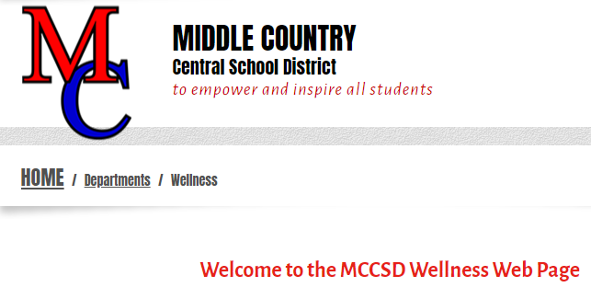 [**https://www.mccsd.net/wellness**](https://www.mccsd.net/wellness)